|  |
| --- |
| **ZEALOUS INTERNATIONAL SCHOOL Jinnah campus**  **2nd CHECK POINT 2024-25**  **Name: ________________ Grade: VII Subject: Maths /25** |

**Q1 (a): Multiple Choice Questions. /5**

1. 7x = 70

a. 6 b. 1 c. -5 d. 25

1. Gradient =

$\frac{vertical change }{horizontal change}$ ______
2. b. $\frac{rise }{run}$ c. both a and b d. axis
3. _______ is a measure of how steep a slope is.
4. Horizontal b. Vertical c. both d. Gradient
5. The equation of straight line is in the form of _________
6. Y = mx +c b. Y = mx - c c. Y = mx / c d. Both b and c.
7. (-5)3 = _______
8. -125 b. +125 c. 225 d. -225Not belong

**Q1 (b): Fill in the blanks. /5**

1. X-axis is always _______
2. Y-axis is always _______
3. The line that slopes upwards from left to right its gradient is ______
4. The line that slopes downwards from left to right its gradient is ______
5. The gradient m is ______

**Q2: Write down the gradient of each of the following. /5**

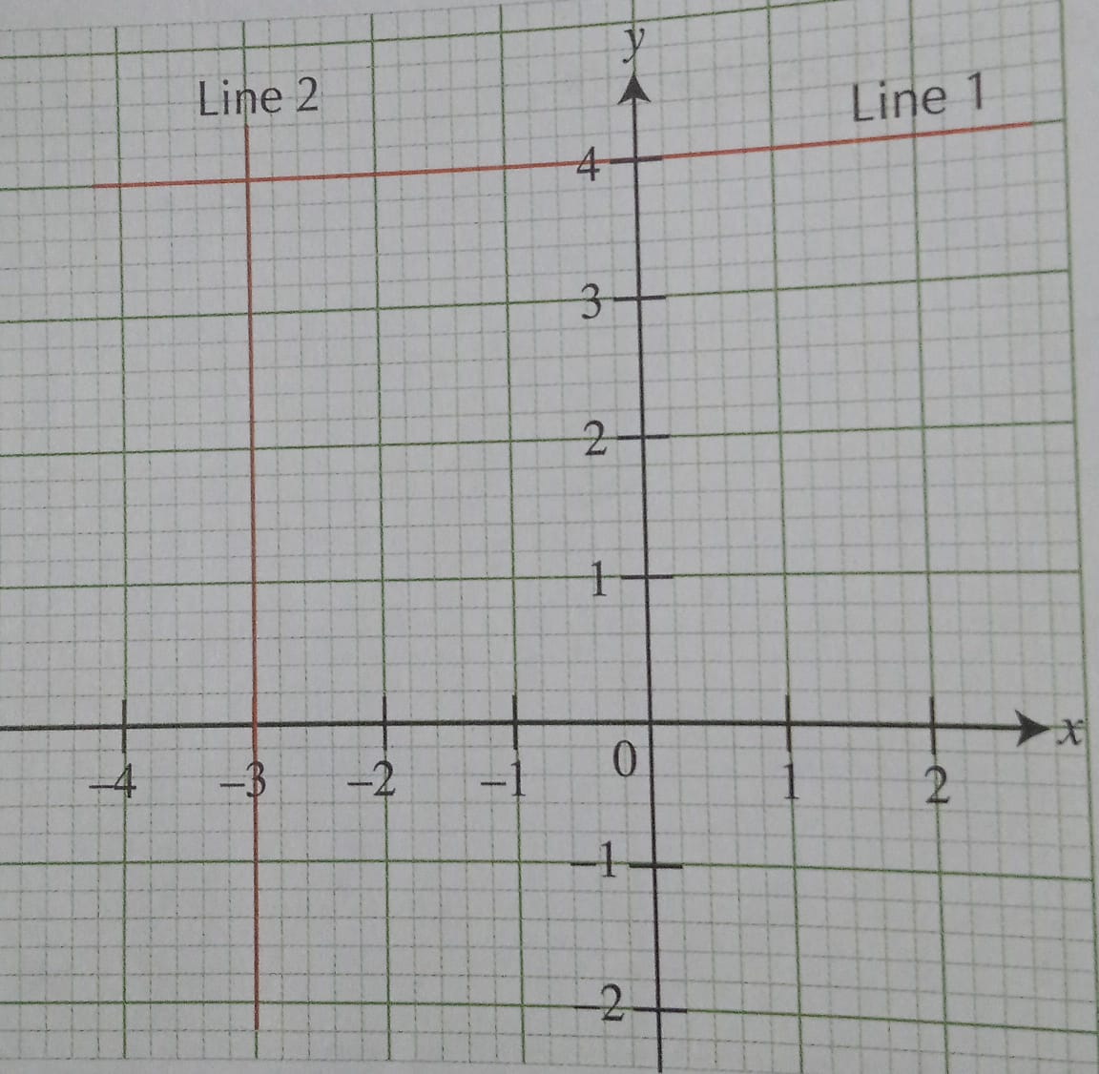

**Q3: Given that the equation of the line representing each of the following linear graphs is in the form Y= mx+c, find the gradient m and state the y-intercepts. /5**

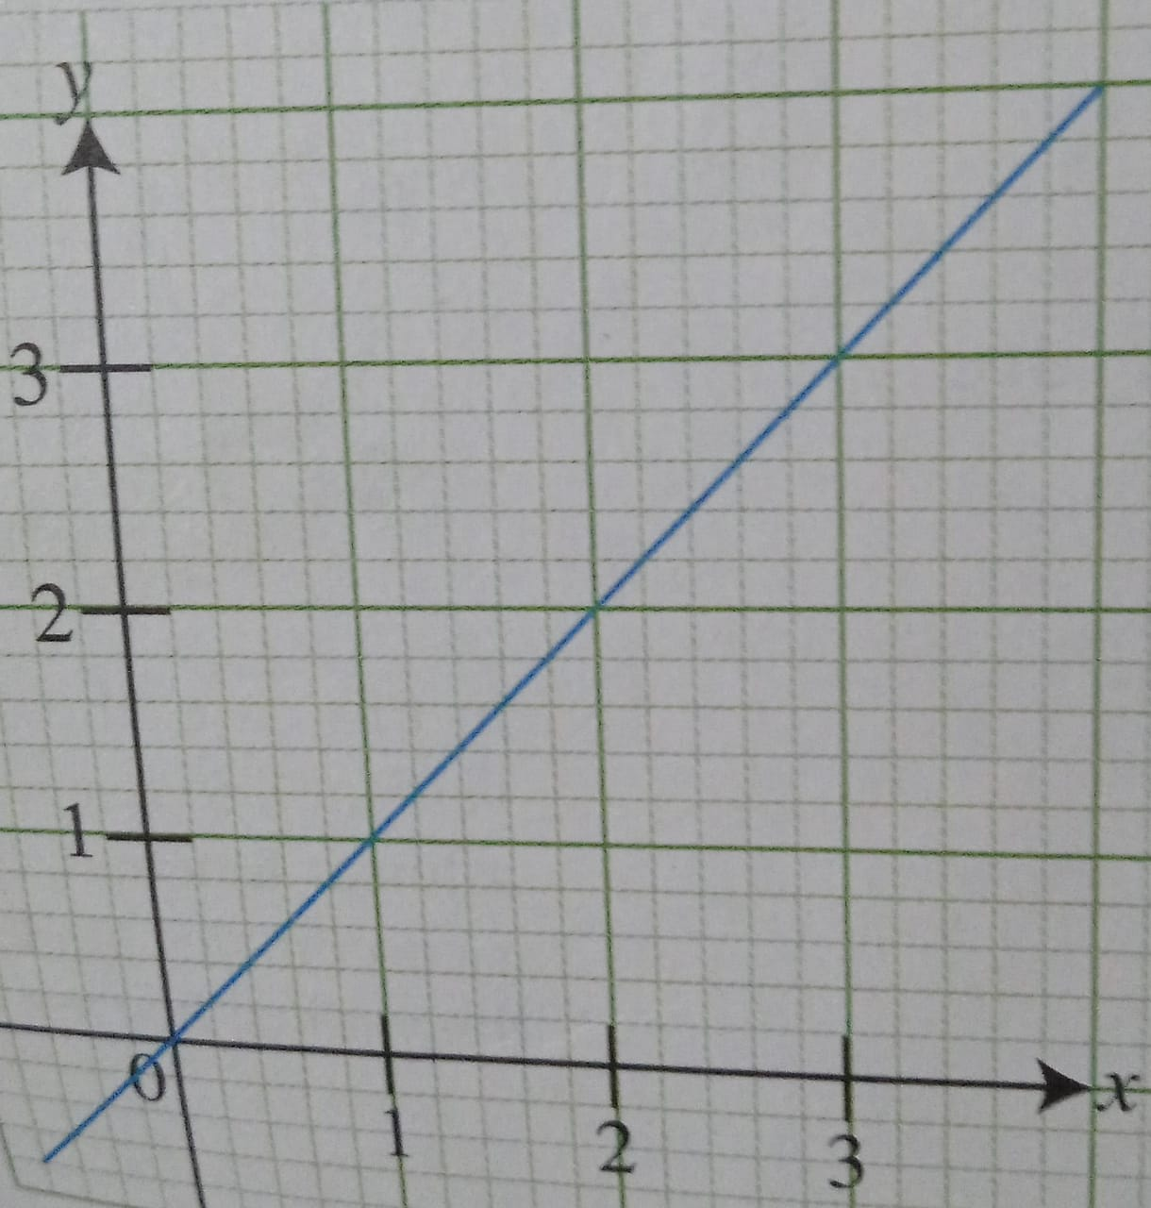

**Q4. Find the gradient of the given line. /5**

